Contents
Classes & Objects

Java Class
class classname // class definition
{
type variablename; // fields declaration
default constructor // constructor declaration
type methodname (parameter - list) // methods declaration.
{
method – body;
}
}
Example :
class Book
{
String bookName;
String authorName;
int noPages;
float price;
String displayname( )
{
System.out.println(“Name of the book is ” + bookName);
}
}
Access Modifiers
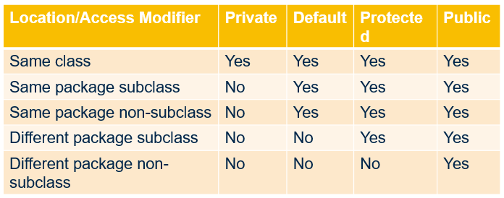
this – points to the current class instance.
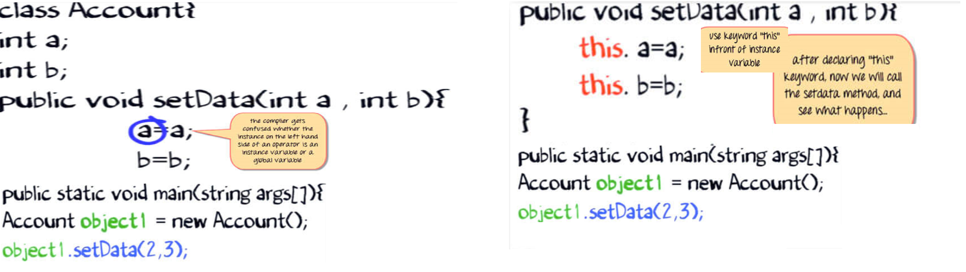

Packages – avoids namespace collision
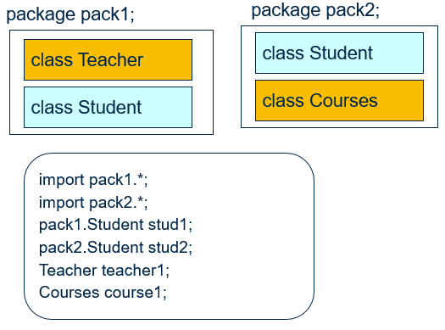
Use * to import all classes in a package.

Package Name | Classes Avaialbe
java.lang | Object class, String class, System class, wrapper classes.
java.util | Utility classes, such as Date & collections (hashmap, treeset, arraylist, hashtable, treemap, etc.)
java.io | Input & output classes for writing & reading from streams & files

Constructors
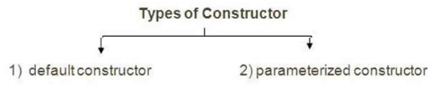
Rule : If there is no constructor in a class, compiler automatically creates a default constructor

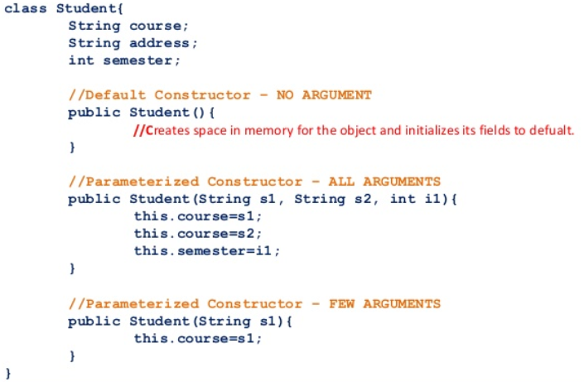

static
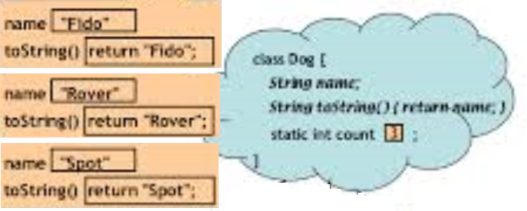
Things which can be marked as static | Methods, variables, nested classes
Things which can NOT be marked as static | Constructors, classes, interface, local variables

